# **TASKS IN WEBCAD V13**

## **TASK 1**

* Change default value of input text box to ‘4000’
* Trigger ‘ok’ button action to enter key.
* Set focus.

### **Change default value of input text box to ‘4000’**

Run the webcad system on your localhost. Take site → free edit.

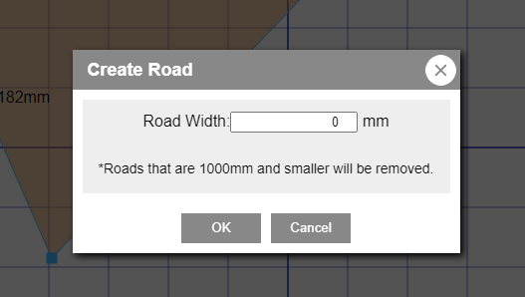

To do task1, make changes in ‘RoadSetting.ts’ file which is in marietta → webcad → view → dialog → RoadSetting.ts.

*if((this.targetSite.itemInfo.dotList[this.index].road_w)==0)*

*{*

*$('#input_roadWidthText').val(4000)*

*}*

Initially , the default value in the input box was ‘0’. So. check the condition as given in the code above and set the value as ‘4000’.

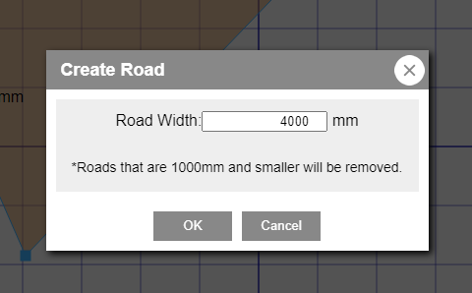

### **Trigger ‘ok’ button action to enter key**

Give enter key the same functionality of ok button using the following piece of code:

*if (event.keyCode === 13) {*

*event.preventDefault()*

*var val = self.$input.val();*

*if (val < self.MIN_ROAD_WIDTH) {*

*val = 0;*

*} else if (val > self.MAX_ROAD_WIDTH) {*

*val = self.MAX_ROAD_WIDTH;*

*}*

*self.$input.val(val);*

*self.updateRoadWidth();*

*}*

*}*

The conditions to be satisfied when enter key is pressed:

1. The road width value must be greater or equal to 1000mm and less than or equal to 10000mm. If this condition is satisfied, road width must increase otherwise not.

### **Set focus to input box when dialog box appears**

Just add the following command to set focus

*$("#input_roadWidthText").focus()*

*where, "#input_roadWidthText" is the id of the road width value.*

## **TASK 2**

### **Camera position is reset when the decoration is changed , keep the camera position after changing Decorations.**

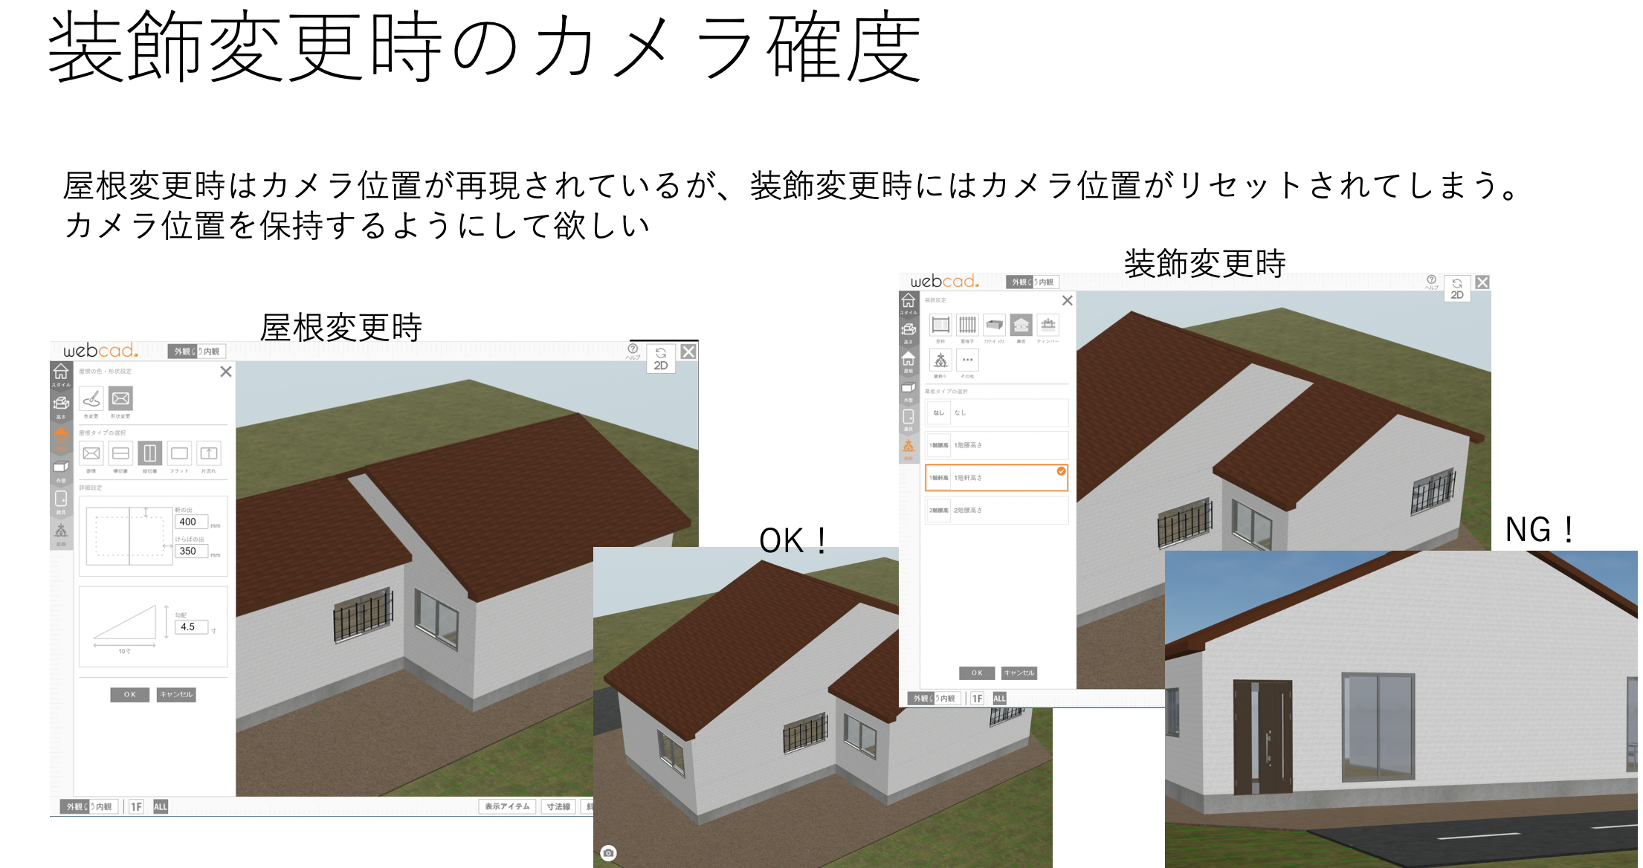

Run the webcad system on your localhost. Take site → draw 2-D plan →convert to 3-D→decorations.

To do task2, make changes in ‘DesignOptionMenu.ts’ file which is in marietta → webcad → view → leftmenu3d → ‘DesignOptionMenu.ts.

*//save camera state*

*marietta.view3d.webcad.View3dGlobal.shared.saveCameraState();*

*//keep camera state*

*marietta.view3d.webcad.View3dGlobal.shared.keepCameraState = true;*

*marietta.webcad.WebCADGlobal.cadAPIManager.request3D();*

## **TASK 3**

* Display the area by dragging within the drawing range in 2D mode

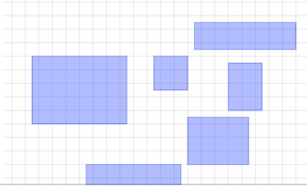

Run the webcad system on your localhost and take ‘Rooms’. Freely drag the mouse which will form the above shown rectangles. The area getting displayed is not disappearing on mouse right click and also on some shortcut key applications like Alt+SPACE, application key, Alt+tab etc.

To fix this bug, take marietta → webcad → control → ItemController_Drag_GroupSelect. Add the following line of code in “initMe()”:

*if($("#dragImageSelect"))$("#dragImageSelect").remove();*

This helps in removing the area whenever its getting formed.

## **TASK 4**

### **Bug fixing of group items for the module FURNITURE.**

* Place group item’s group status even when reselected without being ungrouped
* User can ungroup and then select a single item

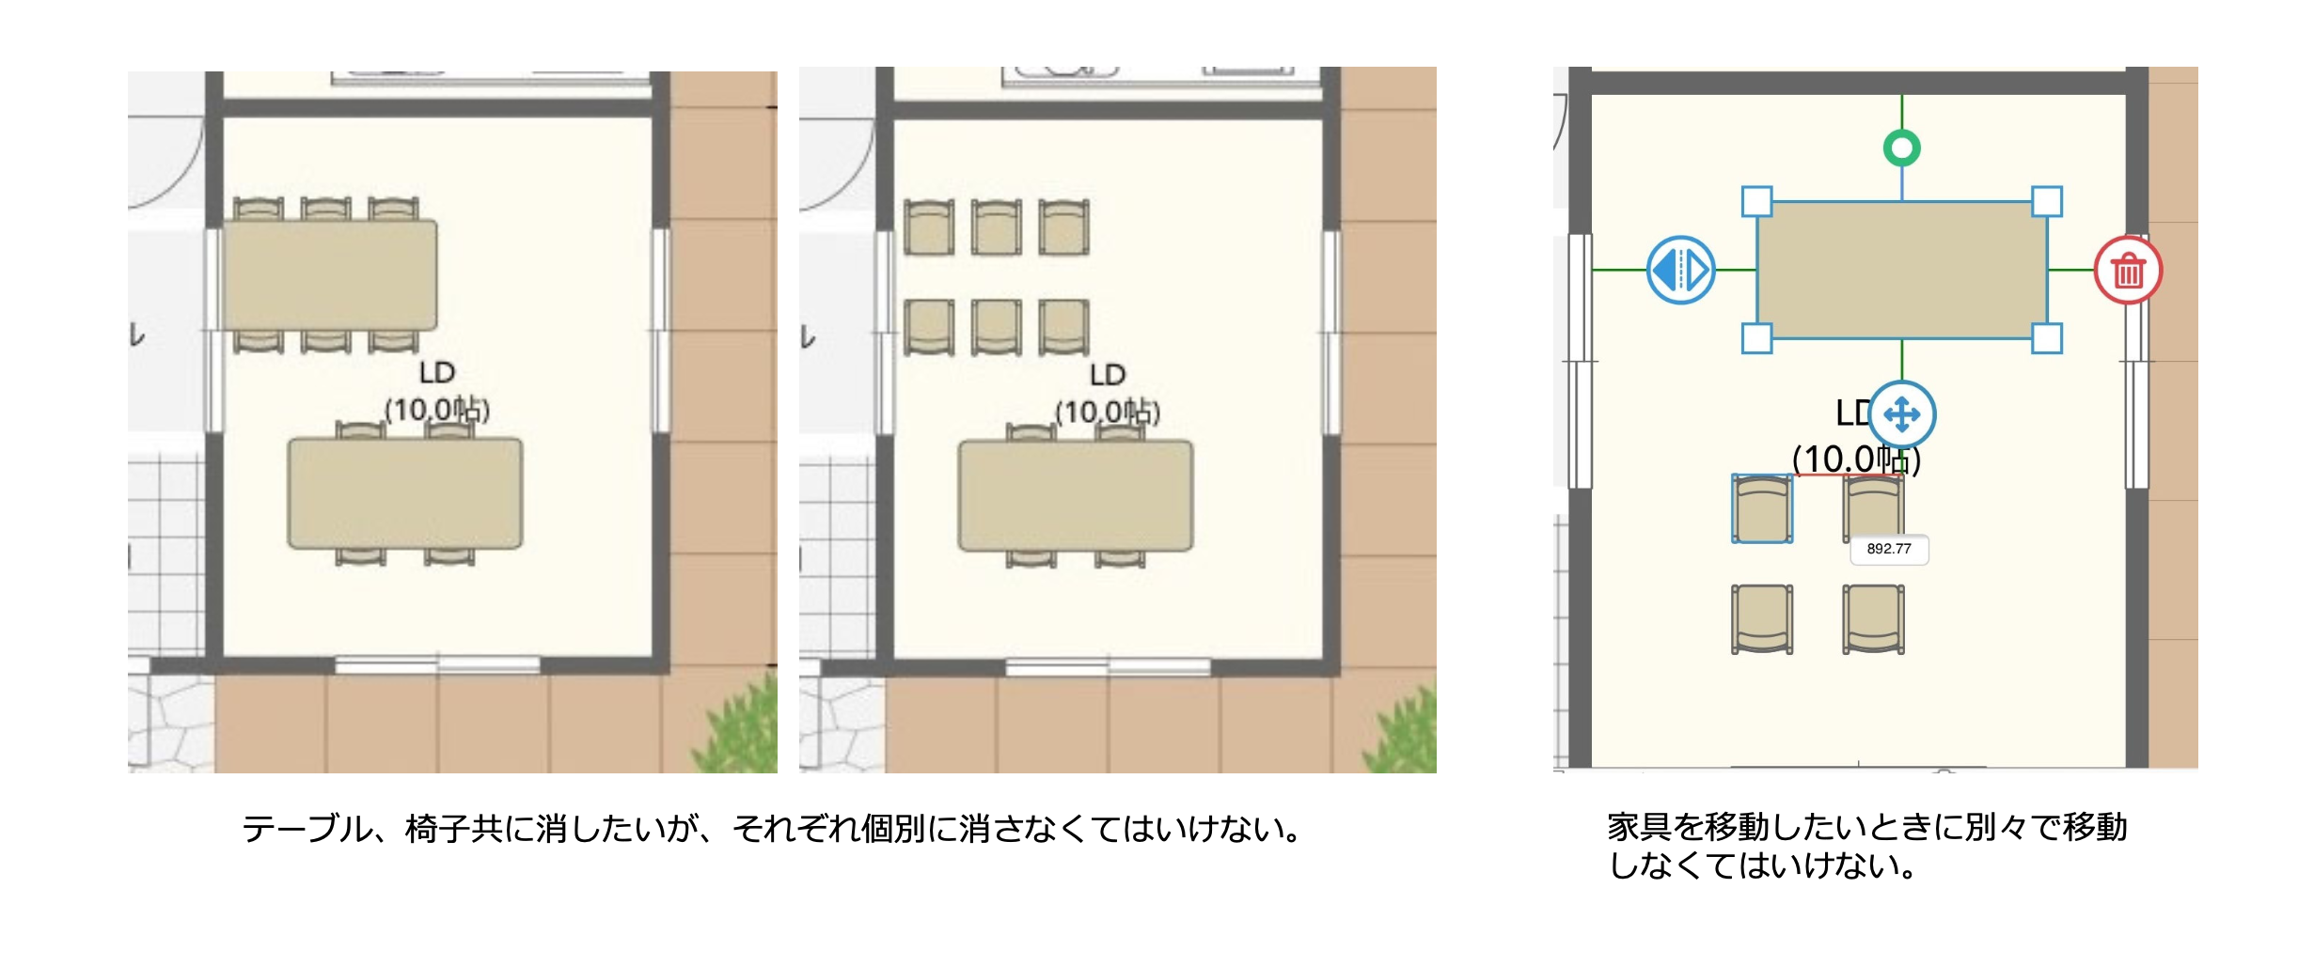

Run the webcad system on your localhost. Take site → draw 2-D plan →Furniture →Drag group items.

To do task4, first make changes in the ‘LayerGroup.ts’ file which is in marietta → webcad → layer → ‘LayerGroup.ts.

*case plan2DManager.ACTIONMODE_SELECT_ITEM:*

*if (marietta.webcad.WebCADGlobal.userAgentManager.isPC && !(marietta.webcad.WebCADGlobal.itemManager.currentItemGroup && marietta.webcad.WebCADGlobal.itemManager.currentItemGroup.isFollowingMouse)) {*

*marietta.webcad.WebCADGlobal.itemManager.startDragGroupSelect();*

*}*

Then make changes in the ‘GroupItem.ts’ file which is in marietta → webcad → item → ‘GroupItem.ts.

*marietta.webcad.WebCADGlobal.itemControlPanel.panelUpdate();*

*marietta.webcad.WebCADGlobal.webcad2Dmanager.saveToHistory();*

*this.createImage();*

## **TASK 5**

1. Create button and list for Pen color selection, Eraser Size selection and Brush Size selection.
2. Please create list Dynamically (use array)

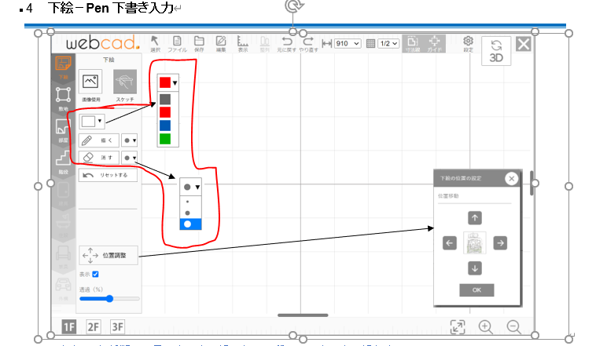

### **Create button and list for Eraser Size selection and Brush Size selection.**

To do task5, first make changes in the ‘dev.html’ file

//combo box for pencolor

*<select name="color" id="penColor" onchange="this.style.color = this.options[this.selectedIndex].style.color;">*

*</select>*

//combo box for pensize

*<select name="sizepen" id="penSize" onchange="this.style.fontSize = this.options[this.selectedIndex].style.fontSize;">*

*</select>*

//combo box for eraser size

*<select name="sizeeraser" id="eraserSize" onchange="this.style.fontSize = this.options[this.selectedIndex].style.fontSize;">*

*</select>*

### **Please create list Dynamically (use array)**

To do task5, first make changes in the ‘Plan2DManager.ts’ file which is in marietta/webcad/manager/Plan2DManager.ts

*static _pencolor:string[]=["#6666","#c22","#22c","#2c2"]*

*static _sketchPen: number[] = [1, 5, 10];*

*static _eraserSize: number[] = [1, 5, 10];*

Then make changes in the ‘main.ts.

//pen

*marietta.webcad.manager.Plan2DManager._sketchPen.forEach(sizepen => {*

*var elementPen = document.createElement("option");*

*elementPen.textContent = "●";*

*elementPen.style.fontSize=(String(sizepen+14))+"px";*

*elementPen.value = String(sizepen);*

*document.getElementById("penSize").appendChild(elementPen);*

*});*

//eraser

*marietta.webcad.manager.Plan2DManager._eraserSize.forEach(sizeeraser => {*

*var elementEraser = document.createElement("option");*

*elementEraser.textContent = "●";*

*elementEraser.style.fontSize=(String(sizeeraser+14))+"px";*

*elementEraser.value = String(sizeeraser);*

*document.getElementById("eraserSize").appendChild(elementEraser);*

*});*

//color

*marietta.webcad.manager.Plan2DManager._pencolor.forEach(colorpen => {*

*var elementColor = document.createElement("option");*

*elementColor.textContent = "*▇*";*

*elementColor.style.color=colorpen;*

*elementColor.value = colorpen;*

*document.getElementById("penColor").appendChild(elementColor);*

*});*

## **TASK 6**

Prepare the 2d plan of every staircases and take a screenshot, get the xml file details.

Draw the 2d plan of a house and include every staircases in it. Take the screenshot. Export the xml file of the 2d plan.

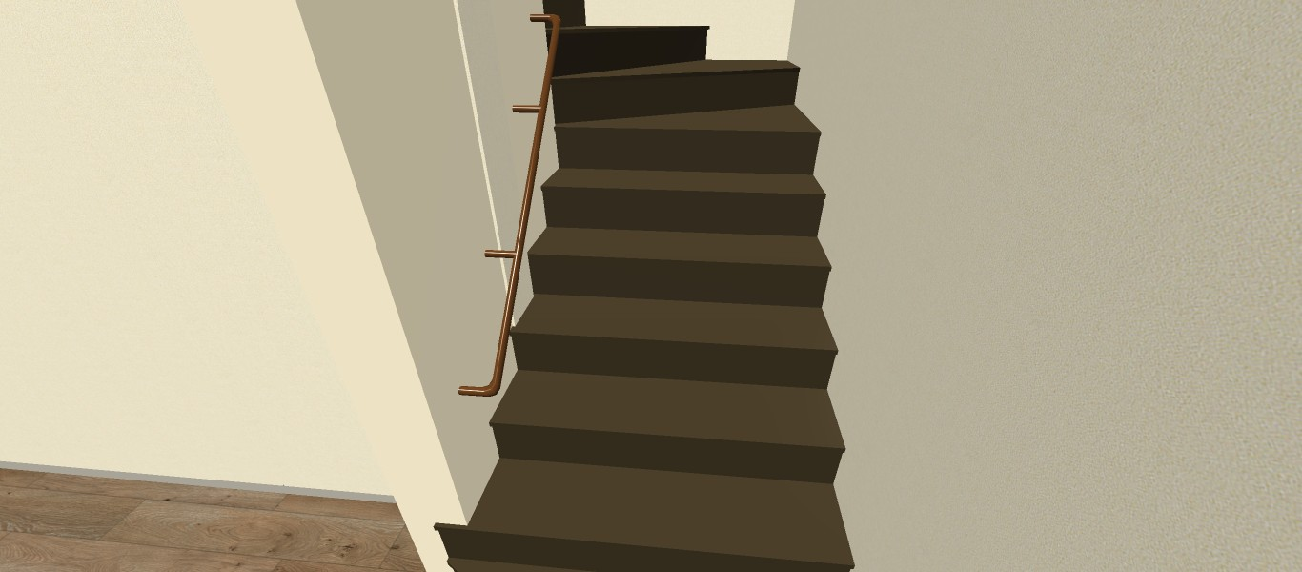

## **TASK 7**

create new stairs 2D screenshots IN metasequoia and update the report .Take a screenshot of the top view of .dae file of every staircase as shown in picture.

## 

## **TASK 8**

Remove <defs> from the stair svg files and place the contents on corresponding elements

In assets → item→ items, there are stair svg files in the form **str20_01_up.svg.** When we open the svg files, we can find the <def> tag. 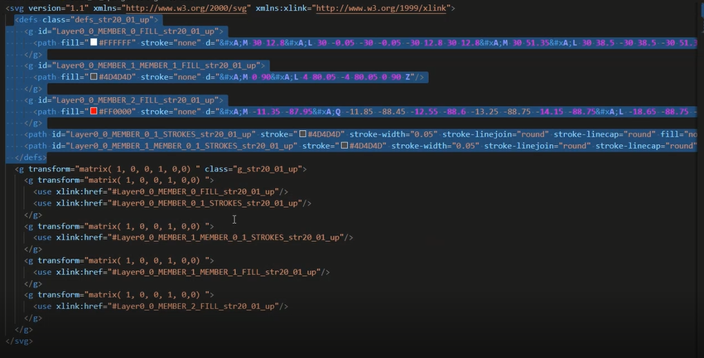

In the image, the <def> tag is highlighted in blue. The code within the <def> tag has to be given within the <use> tag at bottom. Copy the id given in the <use> tag’s “href” and search for it within the <def> tag. Copy it and replace it with the <use> tag. Moreover add **name=’moji’** to the tag as shown:

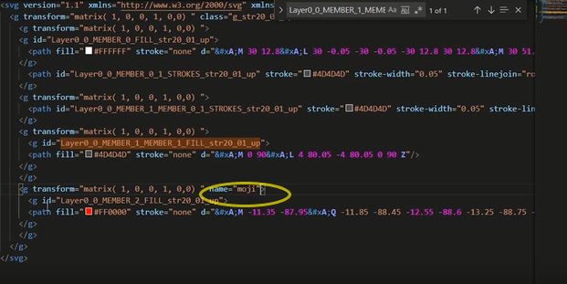

## **TASK 9**

Remove the <def> for interior item svg and place the contents on corresponding elements

In assets → item→ items, there are interior item svg files in the form **equ04_01.svg.** When we open the svg files, we can find the <def> tag.

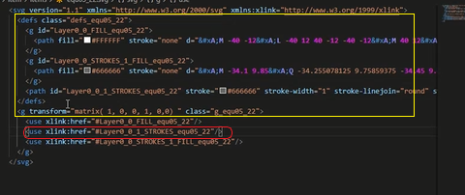

In the image, the <def> tag is highlighted in a yellow rectangular box. The code within the <def> tag has to be given within the <use> tag at bottom(in red box). Copy the id given in the <use> tag’s “href” and search for it within the <def> tag. Copy it and replace it with the <use> tag.